From the Desk of JEFFERY A. SHOCKLEY
Inst. ID. #ES4796
SMART COMMUNICA TIONS/PADOC P. O Box 33028 (SCI MERCER)
St. Petersburg, FL 33733
March 4, 2026
Twenty-Seven Years Inside the Razor Wire By: JEFFERY A. SHOCKLEY
I have lived nearly half of my life behind fences and prison walls. Almost more than outside of them. In 1999, I came in at 37. Now 27 years into a life sentence, the sound of the cold steel doors rolling shut no longer startles me,
It settles into the rhythm of the day the way reveille once did when I wore a different uniform. However, someone walking too close does startle me.
Before I was inmate #ES4796, I was a United States Army Military Veteran. I stood for the flag. I believed in service, in order, in brotherhood. I believed in law. Now I live on the other side of it. This is not a story of innocence.


It is my hope to be a story of responsibility, consequences, and the long shadow that violence, both personal and institutional casts over a life. How suffering silently through trauma, addiction, my actions, impacted others, at least two in particular.
Before the Sentence:
When I enlisted, I was young, restless, and eager to escape childhood traumas. Wanting to belong to something presumed safe, something bigger than myself. The military gave me structure. It gave me pride. It gave me a sense of identity that felt unshakable before being shattered by military sexual trauma.
In uniform, I understood my place in the world. There were rules, clear objectives, and defined enemies. But the battlefield does not stay overseas. When I came home, the noise followed me.
The hypervigilance that once kept me alive became a liability. I scanned rooms. I reacted before thinking. I slept lightly from various fears and insecurities. I carried anger like spare ammunition, ready to load at a moment's notice.
Back then, people did not talk much about PTSD, moral injury, or reintegration failures. You were expected to "be strong." So, I buried what I was feeling. I self-medicated. I isolated. I convinced myself that I was in control, much like what an addict tells themselves. Even as life, family, and relationships deteriorate.
The crime that led to my life sentence did not happen in a vacuum. But neither did it happen without my agency. I made choices, I reacted in rage instead of restraint. A moment of violence erased a lifetime of possibility, for someone else, and for me. The court called it justice. The judge called it accountability. My victim's family called it loss. They were all right.
Policing and the First Contact:
I read over and over the police reports of the night I was arrested, and subsequent court transcripts. Police lights cutting through the darkness like flares. Commands being barked in sharp tones. My body on the pavement, sliced wrists.
There is a strange irony in being restrained by the same state you once swore to defend. I had been trained in use-of-force protocols. I understood tactics. I understood escalation. Yet, on that sidewalk. I was not a veteran. I was not a citizen. I was a suspect.
Policing in America exists in tension. Officers are tasked with keeping order, but they are human beings operating within systems shaped by fear, policy, politics, and bias,
I have met officers since my incarceration who treated me with respect. I have also seen excessive force, indifference, and dehumanization.
The first lesson prison teaches you is that the system is not personal, it is procedural. You are processed, classified, categorized. Your story is reduced to a statute number.
However, the truth is that systems are built by people, and people bring their wounds, assumptions, and power into every interaction. Hurt people, hurt people.
The Machinery of Prison:
If policing is the front door of the justice system, prison is the warehouse. The public imagines violence, chaos, and constant danger. There is some of that, yes. However, mostly, prison is monotony. It is time stretched so thin it becomes translucent.
The first few years were survival. I learned quickly that respect inside is currency. You watch your posture. You measure your words. You avoid debts, financial and emotional.


Then something unexpected happened: time slowed enough for reflection to creep in. In prison, there is nowhere to run from yourself.
No distractions long enough to drown memory pennanently. The cell becomes a mirror. I confronted the reality of what I had done. Not defensively. Not with excuses. Just factually.
The Psychological weight of Life:
Serving a life sentence is not just about years, it is about the psychology of permanence.
When you are told you will likely die in prison, hope becomes dangerous. You ration it carefully. Too much hope leads to despair, when commutation is denied, again, for the 4th, 5th, and 6th time.
Too little hope leads to apathy. Institutionalization creeps in slowly. Decisions are made for you: when to eat, when to stand, when to move, Over time, you stop imagining alternatives, or consider others.
The world outside evolves, technology, language, culture... and you remain suspended in a memory of a different era. Children now grown adults, yet, in the mind, still babies you left behind. I have watched men crumble under that weight, Some turn inward. Some turn violent. Some simply fade into this abyss of alternative lifestyles.
For me, education became survival. Even with a life sentence, reentry began the first day. I pursued vocations, worked in maintenance, honed my writing skills.
Integrating myself did not absolve me. However, it contextualized my fall.
Military Service and Moral Injury:
There is a specific kind of wound called moral injury, the damage done when you act in ways that violate your core values.
I had been trained to use force under rules of engagement. But civilian life has no such framework. When I reacted violently, it was not just a legal boundary I crossed. It was a moral one. The shame that follows is heavier than the sentence.
Inside prison, moving onto a Veteran Services Unit (VSU), I have met other veterans. Different branches, different wars, same quiet struggle.
Many of us were taught to suppress emotion, to default to aggression when threatened. That training serves a purpose in combat. It can destroy you in ordinary life.
There are programs now aimed at Veteran Diversion Courts and trauma-informed policing. I believe in them. I wish they had existed in my time.
Early intervention might have saved lives.
Sincerely, I am careful not to romanticize that thought. The responsibility remains mine.
A Critique of the System:
After nearly three decades, I have observed patterns. We incarcerate aggressively. We police heavily in poor communities. We treat addiction as crime until it becomes profitable to treat as illness.
We warehouse the mentally ill because treatment infrastructure is thin.
Prisons are filled with trauma. Perpetrators who were once victims, children who grew up in violence, veterans who never decompressed, addicts who numbed pain with substances.
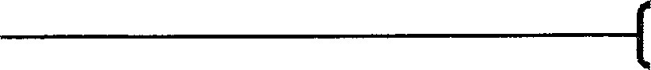

Life sentences, particularly for crimes committed by young adults, raise hard questions. Neuroscience tells us the brain continues developing into the mid-twenties. Yet, we impose permanent judgments on decisions made at 18, 1 9, and 20. Accountability is necessary. But your existence is hopelessness. Condemned to life in prison leaves little to nothing to look forward to, this is when one realizes the true value of life.
A system that leaves no room for transformation contradicts the very concept of rehabilitation. If people are capable of change, and I have witnessed profound change behind these walls, the policy should reflect that capacity.
Redemption and Responsibility:
Redemption is a complicated word in prison. Some see it as a religious tern-I. Others as naive optimism. For me, redemption is not about erasing the past. It is about living in a way that acknowledges it. Giving honor.
I am a State Certified Peer Support Specialist (CPS) dealing with mental health. mentoring younger inmates now. Many arrive angry, impulsive, still operating on survival instincts. Fearful.
I see myself in them, as cliché as that sounds, but if I can interrupt one cycle, encourage one man to pause before reacting, then some measure of meaning emerges from this confinement.
I have written letters of apology that may never be answered. I have participated in restorative justice programs where victims and offenders engage in dialogue; "Day of Responsibility." Nothing restores what was taken. Yet, does transformation no longer matter?
Twenty-Seven Years Later:
The world outside has changed. Technology I barely understand now governs daily life. Social movements have shifted conversations about policing, race, veterans' mental health, and mass incarceration.
Inside, time still moves in counts, structured moves, instability.
Do I believe in justice? Yes. Though my understanding has evolved. Justice must balance accountability with humanity. It must protect society while recognizing that most harm comes from untreated pain, fractured communities, and systemic neglect.
I am not asking for sympathy. I am asking for complexity. A man can be both a veteran who once served honorably and an inrnate who committed a grave
He can be both responsible and shaped by forces larger than him/her self. He/She can be both punished and capable of growth.
Twenty-seven years is long enough to watch anger burn out and reflection take its place. Long enough to grieve the person harmed, long enough to confront the man I was. Long enough to become someone different.
Whether the state ever recognizes that difference is uncertain. I recognize it. And in a place designed to reduce a person to their worst act, that recognition is an act of resistance.
Final Reflection:

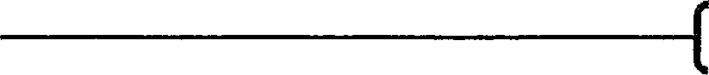
If you ask me what prisons and policing have taught me, I would say this: Force without understanding breeds more force.
Trauma untreated becomes trauma inflicted. Systems that forget humanity eventually lose legitimacy.
I broke the law. I accept the consequences. However, I also believe that a society is measured not only by how it punishes, but whether it believes in the possibility of change.
After twenty-seven years behind razor, I still believe in that possibility. I have to.
Thank You,
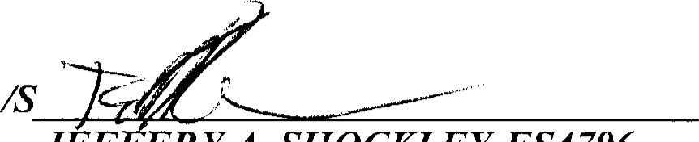
JEF ERYA. SHOCKLEY-ES4796 SMART COMMUNICA TIONS/PADOC
P.O. Box 33028 (SCI MERCER)
St. Petersburg, FL 33733

