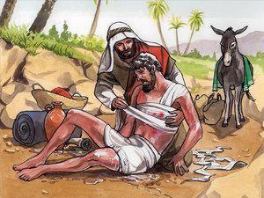
The Good Samaritan
The story of the Good Samaritan is well-known throughout the world, and it has inspired numerous writing and painting for its poignant message of mercy, hope and justice.
We all know that we should help others whenever we can, and we feel better about ourselves and our world when we do. I watch NBC Nightly News each evening at 5:30 pm because I like to keep up on world events of importance. But my favorite part of the news is at the end of the program, when the anchor tells us and shows us the stories of people doing good deeds for others. It is uplifting and inspiring. And it makes me feel there is hope in the world, as long as someone reaches out to be of service to others.
It also challenges me to do more than I am doing. It brings out the best of me, because it shows me the best in others. With that in mind, I felt the need to write about one of the most famous stories in the Bible—the Good Samaritan. I’m sure you know the story. My comments on it may not be new to you, but they come from my heart, and that makes them important for both of us.
I hope you like this book and want to share it with a friend or friends. Additional copies can be purchased from my author website at www.amazon.com/Gene-Allen-Groner/e/B077YTVSJZ. Thanks and God bless.
Please write to me and share your comments about the book and about the things you see or do to be of service to others. The Bible tells us that when you are in the service to others you are in service to God.
My email address is geneallengroner@gmail.com.
Glory be to the Father, and to the Son, and to the Holy Spirit, as it was in the beginning, is now, and ever shall be, world without end. Amen.

