Inspiration from a WWII Veteran

I first met George in my VFW Canteen when he came in with a younger veteran for a beer. We were in the process of playing 15 rounds of bingo that evening, and I couldn’t help but notice that the elderly gentleman who had just sat down at the bar was wearing a WWII baseball cap. I happened to be the “bingo caller” at the time, and I temporarily put the game on hold so that I could introduce myself to this elderly veteran. I introduced George over the intercom to the crowd, and he got a standing ovation from them. In that moment, George knew that he wanted to become a member of our VFW. This story tells of how I came to be very close to George, and how my interaction with him inspired me greatly.

One of the first stories that George was quick to tell me was how he had attempted to request that his military medals be sent to him, as made possible by the US Government. George indicated that when submitting the request - he had no awareness or recognition of ANY awards that he had qualified for (or presented to him).

As the story goes, George (at the age of 92) submitted a formal request to have his WWII military medals be sent to him. For some reason, the request was denied, and George sought the help of a local Pennsylvania Representative to intercede on his behalf.

Some weeks later, George officially received his medals from the US Government. It was at this time, that George became aware of the fact that his records reflected that he had been awarded the Bronze Star, while serving with the Army’s 158th Bushmasters in New Guinea during World War II. As told to me, he received the Bronze Star for his actions in getting seven (7) Japanese snipers to surrender, while serving in the jungles of New Guinea.

Days later, while visiting a veteran friend at the Veterans Administration Hospital in Lebanon, PA - I ran across a hat-vendor who was selling military baseball caps. While purveying his collection of hats, I came across a Bronze Star baseball cap. I knew immediately who I wanted to purchase this hat for!

George was residing in a Senior Home in Carlisle, PA - where I went to visit him some time later to present the Bronze Star baseball cap to him. I wish you could have seen his face - when I presented the cap to George. From the look on his face, you truly would have thought that I just presented him with a brand-new Cadillac.

I was practically shocked to witness that bestowing a $15 baseball cap to this WWII veteran could have such a dramatic impact on him. From that moment forward, George was seldom more than a few feet away from that baseball cap. He was either wearing it, or he had it carefully perched on the bedside table next to him for all to see.

If a person would enter his room to deliver food, or empty his wastebasket, or clean his room - George would proceed to draw your attention to his cap, and he would inform you that “the President of the VFW gave me that hat!” - he would say proudly. George knew that I was a Commander of a Veterans of Foreign Wars Post, and it seemed as if by presenting him with the cap - it was as if I was personally awarding him the Bronze Star - nearly 70 years after-the-fact.
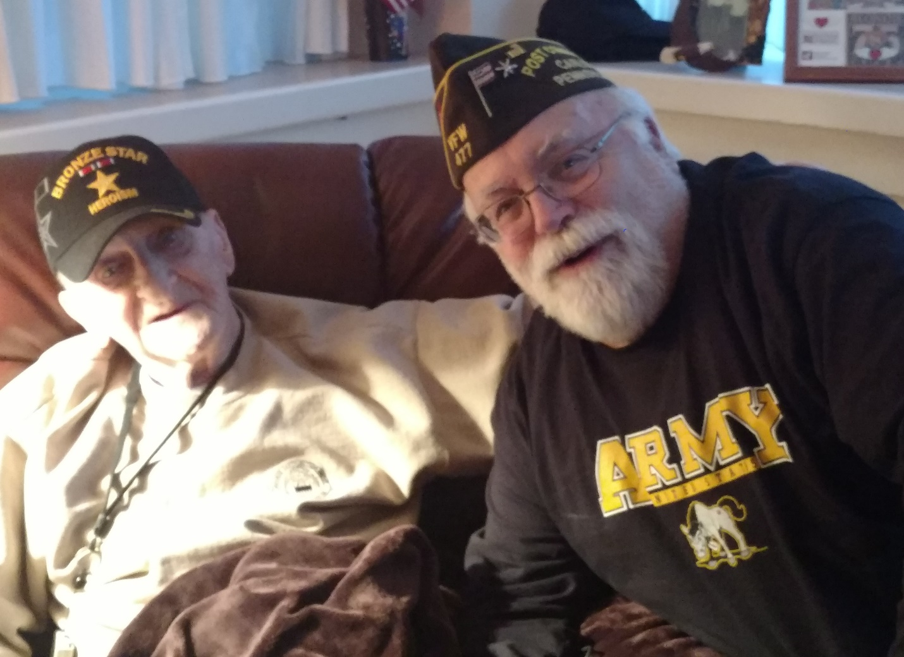

I found the impact of this simple gesture to be profound, and I was deeply inspired by this experience. I was inspired to initiate a program geared towards identifying elderly veterans residing in senior homes in the community; getting to know them; and eventually seeking out, purchasing, and presenting a baseball cap to each of them which captured their personal military journey, and enabled them to proudly advertise how they had served their beloved country. Perhaps it was the name of the ship (e.g. USS Birmingham) on which they had served in the war, or a Vietnam baseball cap, which made reference to an unpopular war in which they had served.

The details of this baseball caps for Senior veterans Program which George inspired deserves a chapter of its own, but I am forever grateful to George for impressing upon me that the smallest of gestures can reap TONS of gratification.

