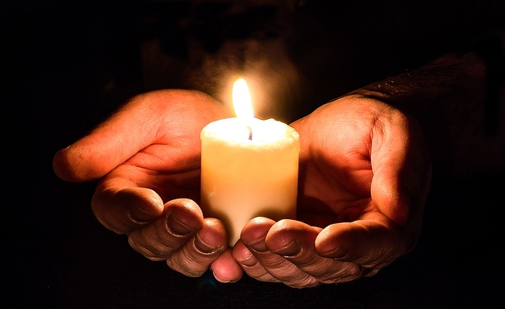

I Believe In Hope

There’s hope in the morning sunrise
When the first light of day shines above
And I hear the song of the meadowlark
Fill the air with joy and love
I believe in hope

There’s hope when a new child is born
When the daffodil blooms in spring
When leaves newly form on the maple tree
And I hear the songbirds sing
I believe in hope

There’s hope in an act of kindness
Helping a child who is lost
Holding the hand of a friend in need
Giving not counting the cost
I believe in hope

So when I’m feeling all alone
With memories that haunt me
I think of all the good I’ve seen
Then I choose the better memory
I believe in hope.

