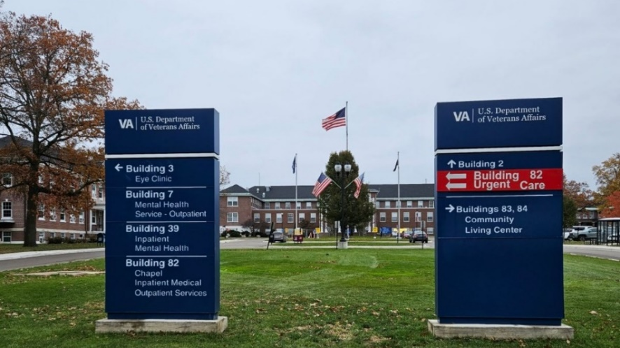
The 100 - Year Old VA Hospital (VISN-10)
Strangely esoteric to all but anyone familiar to those inside the veteran health care community,
which sits adjacent to Dickman and Armstrong Roads; gently rising among the sloping hills of S.W. Michigan, you will find the Battle Creek VAMC. Just follow the early morning procession with their headlights, all in a single row, as it traffic light shifts by a signed landmark of its history. Stating there was a need for a neuro-psychiatric facility due to and for, the year auspiciously 1924, to serve those sent to the cause of the First great World War.
Long gone now those brave but troubled souls, done with their duty and left from wandering this ground into an eternal place. While the restless world keeps winding the wire, some find it strung a little too tight for those whom have made the same trip, and then came back or so we thought…
Because scattered among and like these crestfallen Black Walnut, Birch, Oak and Silver Maple leaves is the same space of feeling, either or neither, being left behind our own camo convoys -- not going forward into the night; our senses attuned to the diesel clatter, voices calling out call-signs and sit-reps chatter, turned up against desert heat and weapons check matters,
all but over now.
Nevertheless it is still the same trench, valley, field, on board, or station; while wearing those little rectangular flags on our sleeves, we’ve all felt the same weight of the Nation that relies on and so remembers our sacrifice, even when it leads to mental health misdeeds. Who still loves and cares for its Veterans, no matter what war, action, or conflict has come and gone before. Until we are all its history.
John S. Copeman
USMC/MIARNG
Bldg. 22 PRRTP
2024
