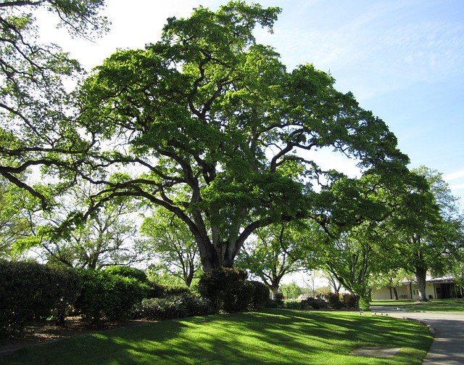
The Oak Tree

Beneath the branches of an old oak tree
I find my greatest peace
A peace beyond eternity
A peace beyond what one might see

The tree itself is very old
Ancient and lovely to behold
Its leaves they reach up to the sky
All the way to heaven they grow

Leaves of wondrous green and gold
Against the clear blue sky
Gently moving with the breeze
Moving my soul in ecstasy

Of all the trees I’ve ever seen
And all the places I’ve ever known
There’s no place quite the same as this
This oak tree is my home

Leaning upon this friend of mine
A sense of peace I feel
A peace more wonderful it seems
Than any I have ever known.

