Full Circle
Many many years ago Chapter 351 of Vietnam Veterans
Of America in Appleton Wisconsin started up with about 20 guys. All wanting to help the community and help veterans like ourselves. A bunch of survivors who had seen it all---done it all—who only had each other when we came home. Today that still exists. We still have each other! The chapter grew and grew over the years and did many good things but got so big the original 20 except a few real good men fade away because too many rules came into effect and many Nam vets can't do rules. I was one of those 20 that faded away years ago. The chapter is really good doing really good work on a local level but could never really see the big picture Nationwide. Years ago it did support Veterans Voices with 300 dollars for three years in a row when our Treasury was 50000 dollars a year. I asked for 500 but got turned down because the chapter wanted to keep money local and was told there are no advertisements in Veterans Voices See what I was fighting? I left the chapter after a meeting that had 150 members there and a big treasury of 60000 dollars as did many other Nam vets who did not like parliamentary procedures and all pretty white shirts that had to be worn when ever we presented our educational display of everything Vietnam to a high school. The best collection of everything Vietnam in the entire Midwest! The chapter still does that but after all these years I attended a meeting yesterday and guess what? There were 20 guys there and the chapter is broke! The treasury is 3000 dollars. I was going to ask the chapter for a donation to Veterans Voices and could not do it! They are cutting everything in order to survive. No more scholorships---take away a storage unit for our education display---no more news letter ( the paper and ink us too expensive), just 20m guys to do all the work exactly like when we started and now it dies! As we Vietnam vets do. We are tired and hurting and old. Yet we carry on just like the 20 left of which I am one of again. To fund raise for the chapterto maybe present again to a high school like I did so many times before. To try and keep the chapter alive. Full Circle! Small Medium Huge Medium and small almost microscopic with nobody able or willing to do the work necessary to keep the chapter going. It was a complete shock to me to find this all out. I never thought I was that old but I am one of the lucky guys to be in great shape compared to so many other Nam vets. Even though I have a ton of disabilities I still function—get by—lmprovise---overcome—carry on! And do what I can! To help—There is no way in hell that I can turn my back on a veteran---any veteran —for I know the price any veteran has paid! Chapter 351 will do the best it can do and not give up until all of us pass into history. For an old soldiger never dies they just fade away!
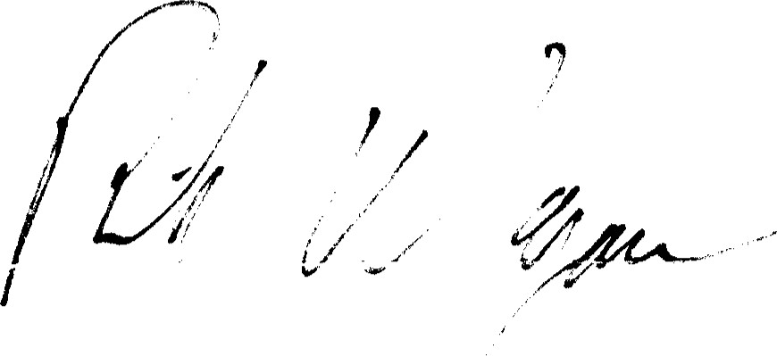
Mr. Richard Wangard
134 Alexander Dr
Neenah, WI 54956-4838

