The Miraculous Staircase

The Miraculous Staircase in the Loretto Chapel in Santa Fe, NM is a double helix design made with no nails, no glue, and no screws.
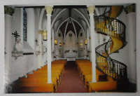
Legend states that seeking guidance and help, the Sisters of Loretto prayed a nine day novena to St. Joseph, Patron Saint of Carpenters. A novena is a special prayer said for nine consecutive days. On the final day of the novena, a carpenter appeared with only a hammer and carpenter’s square. He built what is now known as the Miraculous Staircase with simple tools and wooden pegs. The rare wood is not native to the American Southwest. When the Staircase was complete, it is said that the carpenter disappeared without receiving thanks or payment. The Sisters tried all local lumber stores but could not find accounts open for supplies for their stairs. Some believe the carpenter was St. Joseph himself while others believe that he was someone sent by St. Joseph. What is known is that the Sisters of Loretto prayed, and their prayers were answered
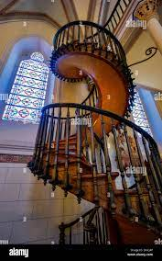
The staircase contains 33 steps to represent the 33 years of Jesus’ life on earth. The unnamed architect/builder of the staircase appeared to the sisters of the chapel one day, volunteered to create the staircase at no charge, and mysteriously disappeared after it was completed.

