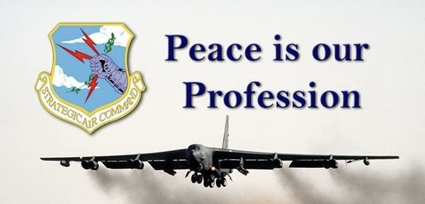
Here it is !

The Miami VA National Creative Arts Festival
Creative Writing
Special Recognition
Winner

The American Fighting Man’s
Emotional Psychiatric Burden

As I progress through my fifth decade of relationship as a patient with the Miami VA psychiatrists, my attention comes to the idea that the study of the American Fighting Man should be a distinct, separate, and unique field of required knowledge studied specifically by all VA psychiatrists for reduction of the veteran suicide rate. It is acutely evident to me that zero and nil VA psychiatrists have the experience of fighting and killing for our American people. This void can be partially ameliorated by the purposeful directed study of the emotional and intellectual composition of the American Fighting Man before, during and after war.

Parochial and insular areas of study such as 9/11 victims, homosexual, transgender, geriatric, autism, forensic, and child psychiatry have clearly dominated the minds of the men who are responsible for the understanding, care, and treatment of the VA’s American Fighting Men clients. These fighting warrior men have a heart and mind chock full of the trials of the assigned and necessary killing of enemy combatants and civilians and the tortures of trying to be accommodated and assimilated back home by a war and killing-ignorant civilian population. The attempted repair treatment by equally ignorant teams of VA psychiatrists spreads despair and insult to injury engendering in the veterans's hearts a sense of betrayal by the very people he killed for. Betrayal and despair lead to suicide.

During my decades of experience with Miami VA psychiatrists , I have found that their necessary knowledge of the killing-oriented, death-emotion filled American Fighting Man has been side tracked by the VA psychiatrists quick and easy interest in and exposure to peripheral non-core areas of easy study and easy experience such as 9/11 victims, homosexual, transgender, autism, child, forensic, and geriatric psychiatry.

These psychiatry subjects may be fascinating to study, learn about, and discuss, but they are not core to the nature of the vast majority of our America’s fighting men who kill our country's enemies as a profession.

VA psychiatrists just do not seem to grasp the long term psychiatric problems of our men who kill professionally for our countrymen. This is where the 20 suicides per day come in. The American Fighting Man is essentially The American Killing Man. His pain and anguish from the stigma of killing has often caused an unbearable burden to carry alone forever.

Killing is the core of combat. Combat is the core of the American Fighting Man whom the VA is mandated and funded to serve. Reduction of our veteran suicide rate requires VA psychiatrists dealing head on with the killing the veterans have done, just as the veterans must.

VA psychiatrists must no longer ignore the silent pleas for help from the warriors who have done our Nation’s killing and are now on the outskirts of VA care.

No employee psychiatrists have a mission charge for excellence more necessary than those of the VA.

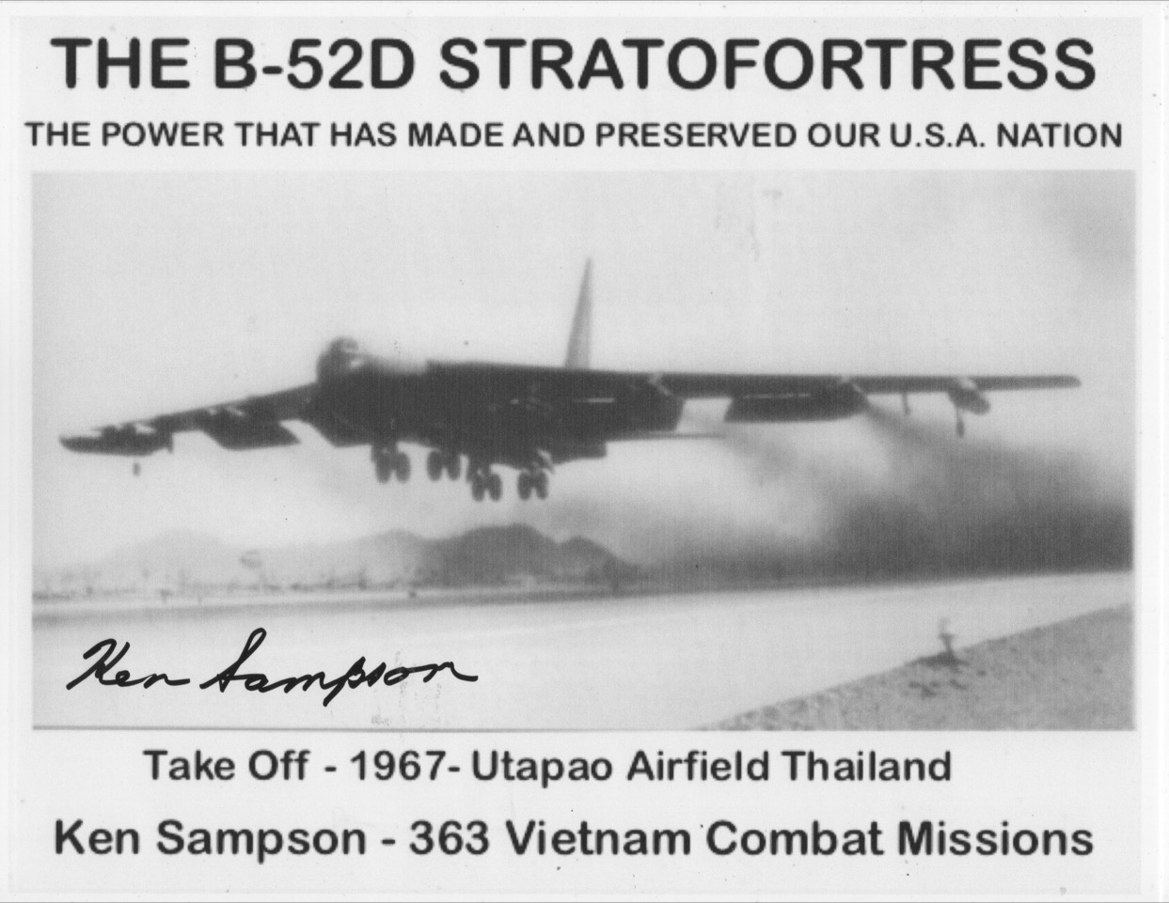
Suicide reduction will surely follow a philosophic and in practice VA return to: “To care for him who shall have borne the battle, and his widow, and his orphan”.

