Habitat for Humanity

For ten years I volunteered to build houses with Habitat for Humanity International. I give all the credit to God, for he is the One who introduced me to HFHI and the tremendous work they do all around the world. Here is my brief testimony of how I happened to find Habitat for Humanity. I think it all started around 1980.
When the opportunity arose to work on a house for Habitat for Humanity, I was excited to help. I thoroughly enjoyed the experience, and decided it was a ministry I could do without too much difficulty. I didn’t know much about carpentry and house construction, but I am a quick learner. With practice working on several houses, I learned to measure and cut lumber properly, to cut and hang trim pieces around doors and windows, and how to apply paint both inside and outside the way professionals do. It was a great way to develop some skills that are useful on my own house.
It was about that time when I received an unsolicited letter from Rosaland Carter, Jimmy Carter’s wife, asking for donations and volunteers. So I wrote to Jimmy Carter in Atlanta, Georgia, the best-known volunteer I knew of, and asked him how I could go about starting an affiliate, or chapter, in my area. He responded with some information and brochures, and suggested I contact the international headquarters in Americus, Georgia. I wrote them and received a packet of materials designed for starting an affiliate. After reading the materials and making it a matter of prayer, I decided I would start a new affiliate. I followed the steps one by one, beginning with choosing a vice-president and secretary, and then recruiting twelve community-minded individuals to serve on my board of directors. I had no difficulty in recruiting other volunteers, because Habitat for Humanity is a well-known not-for-profit organization with an impeccable reputation.
Habitat for Humanity is a Christian organization whose mission is this:
“Seeking to put God's love into action, Habitat for Humanity brings people together to build homes, communities and hope.”

There is a Scripture I learned as a boy in Sunday school, and it has stayed with me all my life. It summarizes the reason we do community outreach and ministry—glorifying God by serving others. I believe it is a vital part of Christ’s ministry—to serve the poor and those in need. Here is the Bible verse:

“Let your light so shine before men, that they may see your good works, and glorify your Father which is in heaven.”—Matthew 5:16

I had this scripture in mind when I began to inquire about organizing a new affiliate for Habitat for Humanity in eastern Jackson County, Missouri.

One of the requirements for getting an affiliate up and running, and for establishing a continuous flow of income to finance the construction of new homes, is fundraising. I had no experience in raising money, but I knew it was something I had to learn in order for the affiliate to be successful in homebuilding.
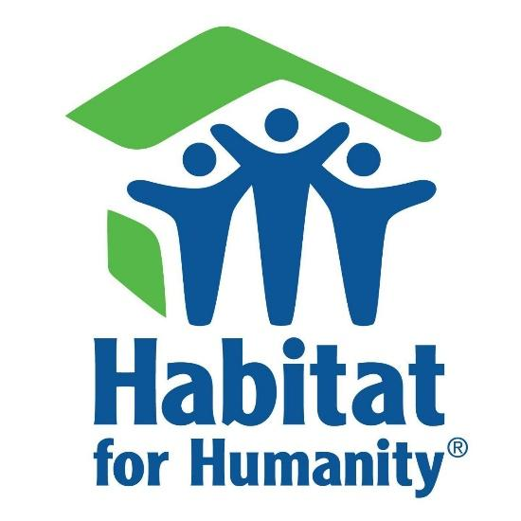
So I started the best way I knew how, with fervent prayer. It is the way that every disciple should begin every endeavor—ask God to show the way. Every evening I got on my knees and asked the Lord for guidance on how to begin fund-raising for the new affiliate.
One night, after several days of praying about it, I had a dream. In the dream I saw myself picking up the telephone and dialing the president of a local bank. When the bank president picked up the phone, he asked me why I called. I answered, in my dream, “I am starting an affiliate of Habitat for Humanity in our area, and I called to ask for your support.”
He answered without waiting for me to explain, “How much do you want?” I didn’t hesitate. I said “I need your gift of $500.” He said “Okay, where do I send the check?” I told him my address, which is the address of record for my new affiliate, and he said he would put the check in the mail that very day. I thanked him and hung up the telephone.
The next morning I awoke and had my answer. The Lord had shown me in a dream how to start my fund-raising efforts, and I thanked God for his help. That very day I phoned the president of a local bank, just as I had done in the dream the night before, and the conversation went exactly as the Lord had shown me in the dream. From then on, I had no difficulty in asking for donations. Almost everyone has heard of the good work the Habit for Humanity organization does for families in need, and they are happy to donate and support the cause.
In order to be a legitimate charitable organization, it is required that the affiliate be incorporated in the state as a 501(c)3 not-for-profit corporation. I have a friend at church who is an attorney, and he was happy to donate his services in this regard. Soon our papers arrived from the state and we were up and running. Learning to be the president and leading a board of directors, with committees for selecting potential homeowners and committees for construction, etc. is not an easy task for a person like me who has had no administrative experience.
Once again, I turned to the Lord in prayer, and he helped me every step of the way. I am deeply indebted to all my volunteers and donors, but especially to my Heavenly Father for showing me the way.
With my team of volunteers and numerous donors, including a large number of individuals and companies, we were able to raise funds and build 11 new homes in eastern Jackson County. After serving for 10 years as the president and lead fund-raiser, I was approached by the Habitat affiliate in Independence and asked to consider them taking over our affiliate and combining forces with them. Over the course of several months all the legal and logistic issues were handled by our attorney and staff, in coordination with HFH International and the Truman Heritage Habitat affiliate. The 11 homes along with all of our resources were transferred to the neighboring affiliate. To date, the combined affiliates have built over 80 houses and provided more than 80 good families with their first, comfortable and safe home to live in.
Habitat for Humanity is a partnership, not a giveaway program—Habitat’s homeowner families buy the houses that Habitat builds and renovates. Habitat homeowners also invest hundreds of hours of their own labor working alongside volunteers. As a result, Habitat for Humanity houses are affordable to low-income families around the world. www.habitat.org
After 10 years of building houses with Habitat for Humanity, I resigned as president and moved on to other social ministries, but my heart is overjoyed with the successes the Lord has provided. He is an awesome God. I love him with all my heart and soul.
p.s. In regards to fundraising, I am grateful to God and those who donated money and materials and time for all they have done to help our homeowners acquire new, safe, and good quality homes we were able to build together. Altogether, I have helped raise over half a million dollars for HFHI. I wish I had kept all the newspaper articles about our affiliate in Eastern Jackson County, MO. There is one in particular of which I am especially thankful. It was a full page feature article in the Kansas City Star, telling about our experience and showing a photograph of me sitting at my desk at Oppenheimer Securities, where I worked as a full-time financial advisor and assistant manager on the Country Club Plaza in Kansas City, MO. I must confess, I am especially proud of that article, and grateful to the KC Star staff and all my loyal supporters. For all of this I thank my Heavenly Father.
As a side note, I have been blessed to raise nearly a million dollars for the various charities I have supported over the years, including Habitat, United Way, CROP Walk for Hunger, World Vision, and Outreach International. Again, all thanks go to God and my supporters.

