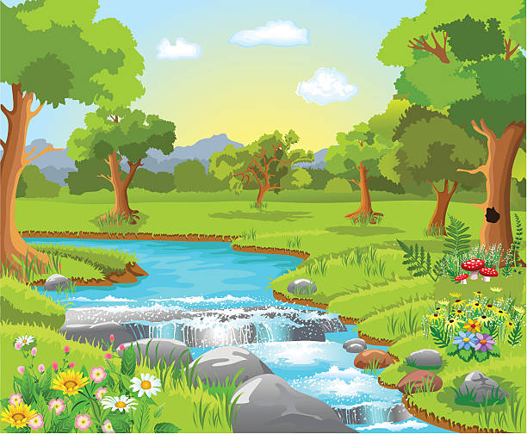
The Garden of Eden

Of all the gardens
That I’ve ever known
‘Tis the Garden of Eden
That’s my favorite home

It lives near the meadow
By trees and a stream
There I leave all my cares
And I take all my dreams

It’s my heavenly home
And everything there
Is peaceful and calm
And the weather is fair

If the day has given me
Sorrow or stress
I travel the road
To the place I love best
Where I know I can find
Near the trees and the stream
My home waiting there calmly
For me and my dreams

If you like, you can join me
As I travel afar
And together we’ll stay there
Out under the stars

We can linger awhile
Maybe spend a few days
Under blue skies above
And the sun on our face

We can mosey along
Past the woods and the stream
And talk about things
We see in our dreams

Dreams of laughter and joy
And days filled with love
In that wonderful garden
Sent from heaven above

We can stay there awhile
For a day, maybe more
Just passing the time
Counting rocks on the shore

In my Garden of Eden
Time is endless, you see
And whenever you want to
You can go there with me.

