Maybe Australia?
Now all this time later---55 years later I have the opportunity to go to Australia and meet up with some friends there in Perth on the west coast of Australia. I want to go for sure . I have money but health is a question mark. I am 74 and have a slew of issues not worth talking about. My wife has given me her blessing and she has always allowed me great freedom. The reason we have lasted over 50 years together. She is a great great person and nobody knows me like her! It is a 30 hour flight and I plan on mid April to visit for 3 weeks with my friends. After I get back it will be the start of riding season but I don't know how more riding is in me as my vison continues to get worse. I have all new computer equipment that magnifies everything so I can continue to write but riding is different and I follow my best friend Wayne and refuse to put him in jepordy when I lose him in the shadows. Things for me are changing and I don't like this getting old crap at all! I want to stay on top of my game but my body betrays me!
I have a bucket list and Australia is on that list! See a kangaroo m in the wild. Go into the Bush. Revive old memories. But never ever ever in the Nam! That is for others who can go and take it! I lost too many friends there and I can't even go to The Wall! I am not normal by any stretch and PTSD still haunts me as I counsel to this day! Understanding friends help me and I have fun with---some are in Australia and I am going to go---a new adventure—a lasting memory to cherish. A mental Health exercise to slay the demons that can show up at any time! I still fight after all these years and there is no surrender only the ability to overcome and improvise. To carry on and do the best I can just like my entire PTSD group of all Nam Vets! Yes all old now but I am here to tell you these old men were and are tough badass men! You under estimate us at your own peril and stupidity. We get some respect now with a Thank You for your service but none of us gives a hoot about that! We all hang with each other still because we trust each other and we know who has our backs! So hello Australia in April and a new Adventure and I will find some of those Aircrew who flew those C-7s and buy them a beer and call them Mate!
You see we were all in the 834th Air Divison flying out of Tan Son Nute. The Aussies flew the most dangerous aircraft The old beat up C-7 Caribu twin engine hunk of junk that could get into anyplace because it was small and could resupply food, ammo, and medical equipment. And it could medivac the wounded too! The Aussies always flew with a smile on their face and a great disposition even though they lost so many great airmen. Yes I lost planes and crew too in my C-130A aircraft but not like the Aussies. Our big C130As could take much punishment from enemy guns but not the C-7s flown by the Aussies! Do you understand why I have so much respect for my Aussie Brothers? How could I not! These Airmen were unlike any others! They called me Mate and many times I could not understand their English but it made no difference . You see we were all in this war together! Now I want to go find some of these airmen still living like I do and talk aircraft and old memories and have a few beers with them and my friends will lead me to them. I am not done yet! Not by a long shot but so prepared anytime God wants to call me back to him and I am ok with that! Just think of the Air Force God Has and wings given out to all the Aussies and Americans. The angles fly and they are not Blue Angles! Thank You my Aussie Mates!
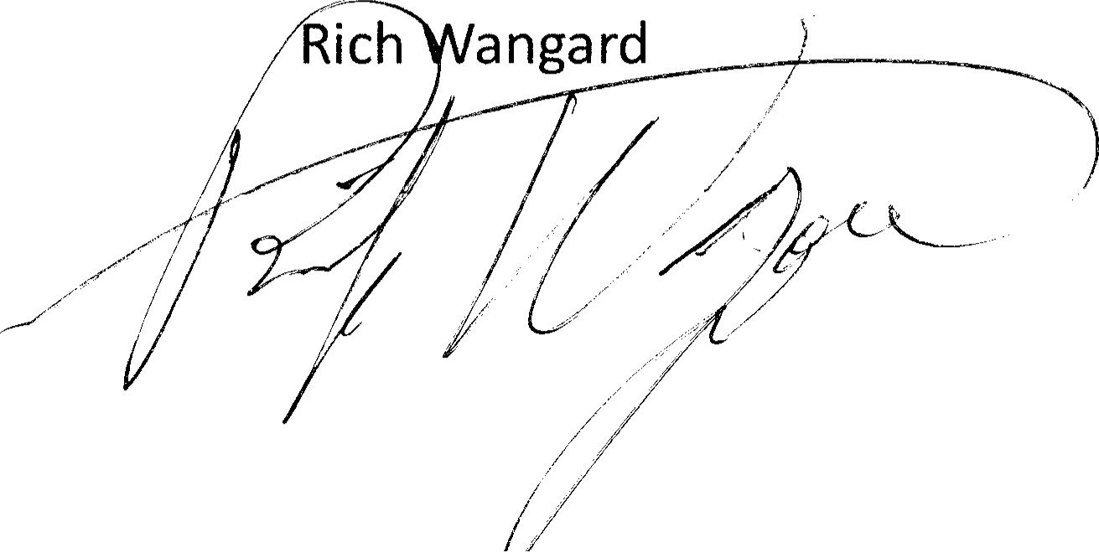Rich angard
vEre Mr. Richard Wangard
134 Alexander Dr
Neenah, WI 549564838

