Topeka Testimony

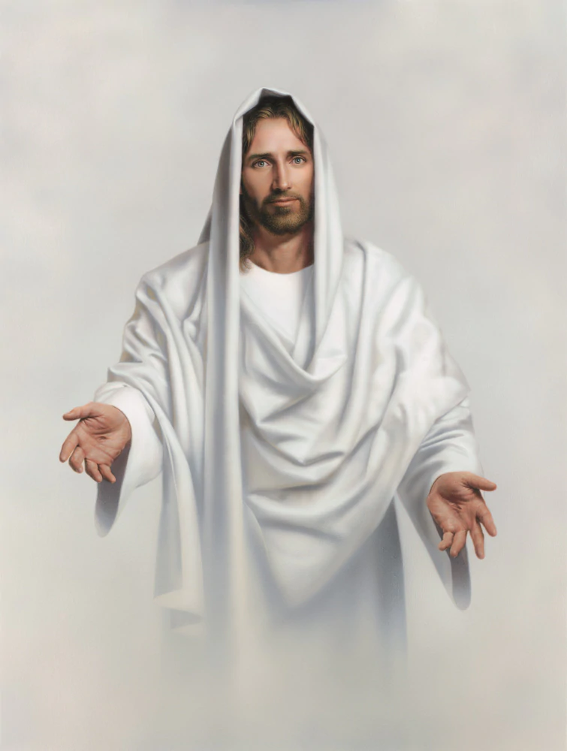

I do not consider myself a visionary. That is for God to decide. I have, however, had many spiritual experiences with the Lord including a vision of Christ. Let me tell you about two of them.

I had an unusual experience when I was 21 years old. I was working evenings and Saturdays at the Harry Turner Advertising Agency in Topeka, Kansas to earn money for my apartment and the cost of the semester at Washburn University. One night as I was walking home from work, which was not far from the university, I paused at a street corner and looked up at the beautiful starry heavens, thinking about how amazing my Creator is to make such a beautiful and glorious sky with the lovely moon and stars and planets, all moving just as God had planned for them.

I was praying and thanking the Lord for his blessings, when I looked up and saw the personage of Jesus coming towards me. He seemed to be about 50 yards in front of me. He was floating above the earth a couple of feet and moving toward me very quickly. It wasn’t difficult to identify who he was, since I remembered seeing paintings of him looking just as I saw him that night. He was wearing a long white robe, as white as the snow. It glowed with a brilliant light, emanating from his whole personage. I remember he was reaching out to me with outstretched arms, not waiting for me to come to him, but coming straight toward me.

When he was about 10 or so yards from me, his image disappeared from my view. It was an unbelievably wonderful vision of the Master which I will never forget.



I can see him again in my mind, just as he was that night long ago. The experience has given me the assurance of his tremendous love for me and for all people. I know without a shadow of a doubt that he gave me this vision because he wants me to have that assurance, in addition to providing me with a vivid testimony to share with others of his never-ending love for me and for all his children. He is forever reaching out to us. Of that I am quite certain.
I firmly believe that he desires for me to share this testimony with others, which I have done whenever I can. It has never concerned me whether others may or may not believe the experience. My responsibility is to simply tell the story and leave the convincing up to the Holy Spirit, whose work is to reveal truth and light. I have great joy in being able to write of this experience, so that it will be recorded forevermore for others to read.

But that’s not all. On another occasion, I was in my apartment in Topeka, reading the Bible my Grandmother Ada had given me as a graduation gift upon my high school graduation. I recall pausing to pray that God would tell me if these things I was reading in the Bible were true, and if all the things I learned in church as a young boy growing up in Marshall, Missouri were true also. I had come to question these things while I was serving in the Marine Corps and far away from home in the South Pacific.

Immediately after praying this way, I felt the power of the Holy Spirit come upon me, lifting me up out of my chair and standing me straight up in the room. The power was so great that I had to ask God to please release me, or I might be consumed by it. The Spirit left me, and I fell to the floor, barely able to grasp what had just happened. In the following moments my mind was quickened, and I felt the quiet assurance of the Holy Spirit, which was very comforting and gentle this time

When I realized what had happened, the knowledge came into my mind that my questions had been answered. I knew that what I had read in the Bible, and the things I had learned from church as a child were completely true. From that moment on, I have never once doubted the truth of the experience, or the fact that the Bible and my childhood education in the church were true and reliable. As I share this experience now in this book, I can say without any doubt whatsoever that I know these things to be true. That is my testimony today, the same as it was when I was 21 years old in my apartment in Topeka. I remember the experience perfectly well today, just as if it were yesterday. As to the truth of the experience, I have never once had a doubt.
It is all true, exactly the way I described it.

These two experiences are very real to me—I know that I didn’t imagine them—they happened exactly as I have just written them in this book. I don’t in any way share these things to indicate that God revealed himself to me in this way because I am special. I am not. I am just an ordinary Christian who has been blessed with extraordinary blessings of the Spirit. God shows me these things for his own purposes, whatever his reason may be. It is my job to tell them to others, and to let the testimonies stand on their own merits. I don’t attempt to convince anyone of anything. I only try to be faithful to my Lord, and to share my personal testimony of the things I have seen and heard. God and the Holy Spirit will do the convincing. Thank you for letting me share my experience with you. God bless you.

