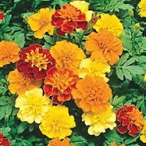
Marigolds

After reading Christine Hazuka’s Fall 2024 Veterans’ Voices article titled The Hollyhock Dolls, my mind went back to my childhood, where I grew up in the small town of Marshall, Missouri.
I remember my grandparents’ patch of orange and yellow marigolds planted alongside the garage next to their one-bedroom home on South Ellsworth street. I can still smell the spicy fragrance of that marigold flower garden, and I can still see the hundreds of honeybees moving from flower to flower, drinking the marigold’s sweet nectar.
The hours I spent at my grandparents’ house have given me some of the best memories of my life - Grandpa Henry sitting in his big maroon easy chair smoking El Roi Tan cigars and reading the Daily Democrat News, the town’s only newspaper; Grandma Ada crocheting beautiful rugs out of the colorful rags she had torn up and stitched together; my friends and I playing marbles in the back yard near the garden of marigolds.
These were the best of times.

