I would like to tell you a personal story about angels and why I believe in them.

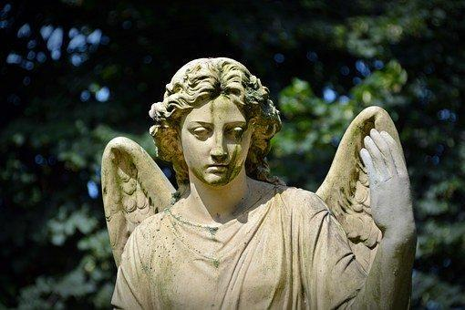

"For he will charge his angels on you, to guard you in all your ways."
__Psalm 91:11

Since I was eight years old and in third grade, I have believed in angels.
On my bicycle ride home from the grocery store one Saturday morning, I was hit by a car and hit in the ditch. The car didn't stop to check on me. A little disheveled but otherwise unharmed, I brushed off and made it home safely. Mom met me at the door and could easily see my dirty shirt. Showing no surprise, she asked, "Are you okay?" When I told her what had happened and she could see that I was fine, she said, "I knew you would be safe because I prayed to God that he would send his angels to protect you. From that moment, I knew the angels were real, even though I couldn't see them.
Most recently, in 2018, I was involved in a car accident and woke up in a hospital. I barely remember the accident but will never forget how I was saved by an angel. The accident happened in the country. For miles around, there was no one but me. I hit a railing and totaled the car. I later learned that a young woman named Rachel found me and took me to the hospital. I never saw her, I never heard her voice. But I knew without a doubt that God had sent an angel to save me.
God has always revealed himself through the ministry of angels. In chapter six of the book of Daniel, God sent an angel to shut the jaws of the lions after Daniel was thrown into the den of lions. And we all know the announcement of the angel Gabriel to Mary:
"The Holy Spirit shall come upon you, and the power of the Most High shall overshadow you: therefore this holy thing which shall be born of you shall be called the Son of God" (Luke 1:35).
In her book, The Hiding Place, Corrie ten Boom recounts her remarkable experience in the Nazi concentration camp in Ravensbruck. Upon arrival, she and her sister Betsie, along with all the other prisoners, were instructed to remove all their clothes and put them in a pile. They then received their prison robes. The guards then searched the women before taking them to their barracks. Corrie had a Bible hidden in her clothes, as well as woolen underwear for her sister. These items bulged into her dress and could easily be detected by the guards who searched the women again before taking them to their barracks. Before the final search, Corrie ten Boom prayed, "Lord, now make your angels surround me, and not be transparent today, for the guards are not to see me." The woman in front of her had hidden a woolen waistcoat under her dress. It was taken from him. They let Corrie pass because they didn't see her. Betsie right behind her was searched.
Miracles happen today as they did in Old Testament and New Testament times. Angels continue to serve in our lives today, as they have throughout history. They watch over us and protect us, and they always guide us to do our Heavenly Father’s perfect will. We may not see or hear them, but they are real and they are all around us.
The Bible reminds us,
"Be not forgetful to entertain strangers: for thereby some have entertained angels unawares."
— Hebrews 13:2 KJV

