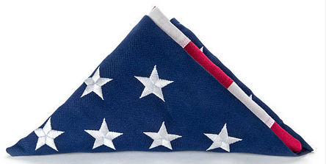
Freedoms Terrible Price

The terrible price of freedom
No one fully understands,
Until a folded casket flag
Is placed into their hands.

©Ron Tranmer

