The Training Accident
By SFC Steve Arbuckle (US Army, ret.)

As I approach my 69th year, I find that some memories fade but do not disappear. When they're good, it's a moment to savor. Those that are not, or have a mixture of emotions return when I am out and about on my own, usually taking a long walk with one of our canine companions.
This is one.
Our unit at Fort Knox was a combat deployable one. However, we also supplied tanks and men to the armor school as training support for upcoming officers and senior NCOs. We were tasked to send an M1 tank with skeleton crew of two (complete crew is four) to a training area for some class in the field. The NCO in charge of this detail was Sergeant Farmer*.
He was a very good NCO; young, capable, a leader of confidence and promise.
Later on, the day of his being sent into the weeds of the training area we received a disturbing call from headquarters. There had been a training accident. Inside the tank, SGT Farmers skull had been severely fractured between the 105mm main gun and the roof of the gun turret. His combat vehicle crew (CVC) helmet had provided little protection against the hydraulic force of the gun breech moving swiftly upward. He was unconscious and airlifted to Ireland army hospital.
The accident investigation team from Anniston, Alabama arrived. Coincidentally, the head of the team was SGT Farmer’s old company commander. He afterwards concluded a malfunction of the gun system was likely the source.
He went into a coma from which he never returned. The Army decided to medically retire him after it was determined that he was permanently injured. He was promoted to the rank of staff sergeant so his family could receive additional benefits. They released him to his wife but provided for all possible medical care and assistance.
Sometime later I was on rear detachment and pending my retirement, assigned to assist the corps of engineers in building maintenance of the battalions' various structures. News reached me that SGT Farmer had passed on at home in Elizabethtown, Kentucky. I got the date, location, and time of his funeral and attended in dress uniform.
In my younger days I was often on funeral detail as a pallbearer while assigned to a tank unit at fort Carson Colorado. It was usually an annual two week stint on call. Our place of duty was the national cemetery outside of Denver. We trained with a mock casket to provide the full-on honors; pallbearers, firing party, bugler. Our uniforms were tricked out with polished helmet liners, white shoelaces in spit shined boots and white pistol belts.
Years later as a senior NCO at fort Knox I was placed in charge of funeral details from time to time. One was to provide a complete compliment for a retired brigadier general in Cincinnati, Ohio. Another occasion it was to provide the community and next of kin in West Virginia the well earned recognition for a survivor of the horrible Bataan death march of World War II.
This was the mid-1990s now, and things had changed. It was left to the local command to determine what honors they could provide. Not until the year 2000 was it mandated by congress as the minimum to be provided all veterans: When a soldier dies and is not killed in combat or on active duty, the most he or she usually received is a plot if requested in a local national cemetery, a flag, two uniformed members of his branch to fold the flag, and a tape recording of taps. His wife and family were bereft.
As soon as my old unit came back from deployment, I told SGT Farmers platoon sergeant, sergeant first class “.50 cal AL”, what happened.
From there we devised a plan. First, we needed the folded funeral flag from the widow. SFC Al took care of that by borrowing it and gave it to me for measuring. I took it to my little wood shop and made a display case for it. Then we got the captain and the chaplain to sign off on a full-on memorial service for the fallen and his family.
The widow attended with SFC Al’s help. In the old World War II chapel across the street from our billets we rendered the overdue honors. Outside, a bugler from the 194th Armor Brigade band played taps following the standard three volleys our troopers gave near the entrance.
What congress would not allocate funds for nor his unit find personnel, we took care of on our own for a fallen comrade. Mrs. Farmer was re-presented on behalf of a grateful nation the colors, folded and encased.
I will not forget.
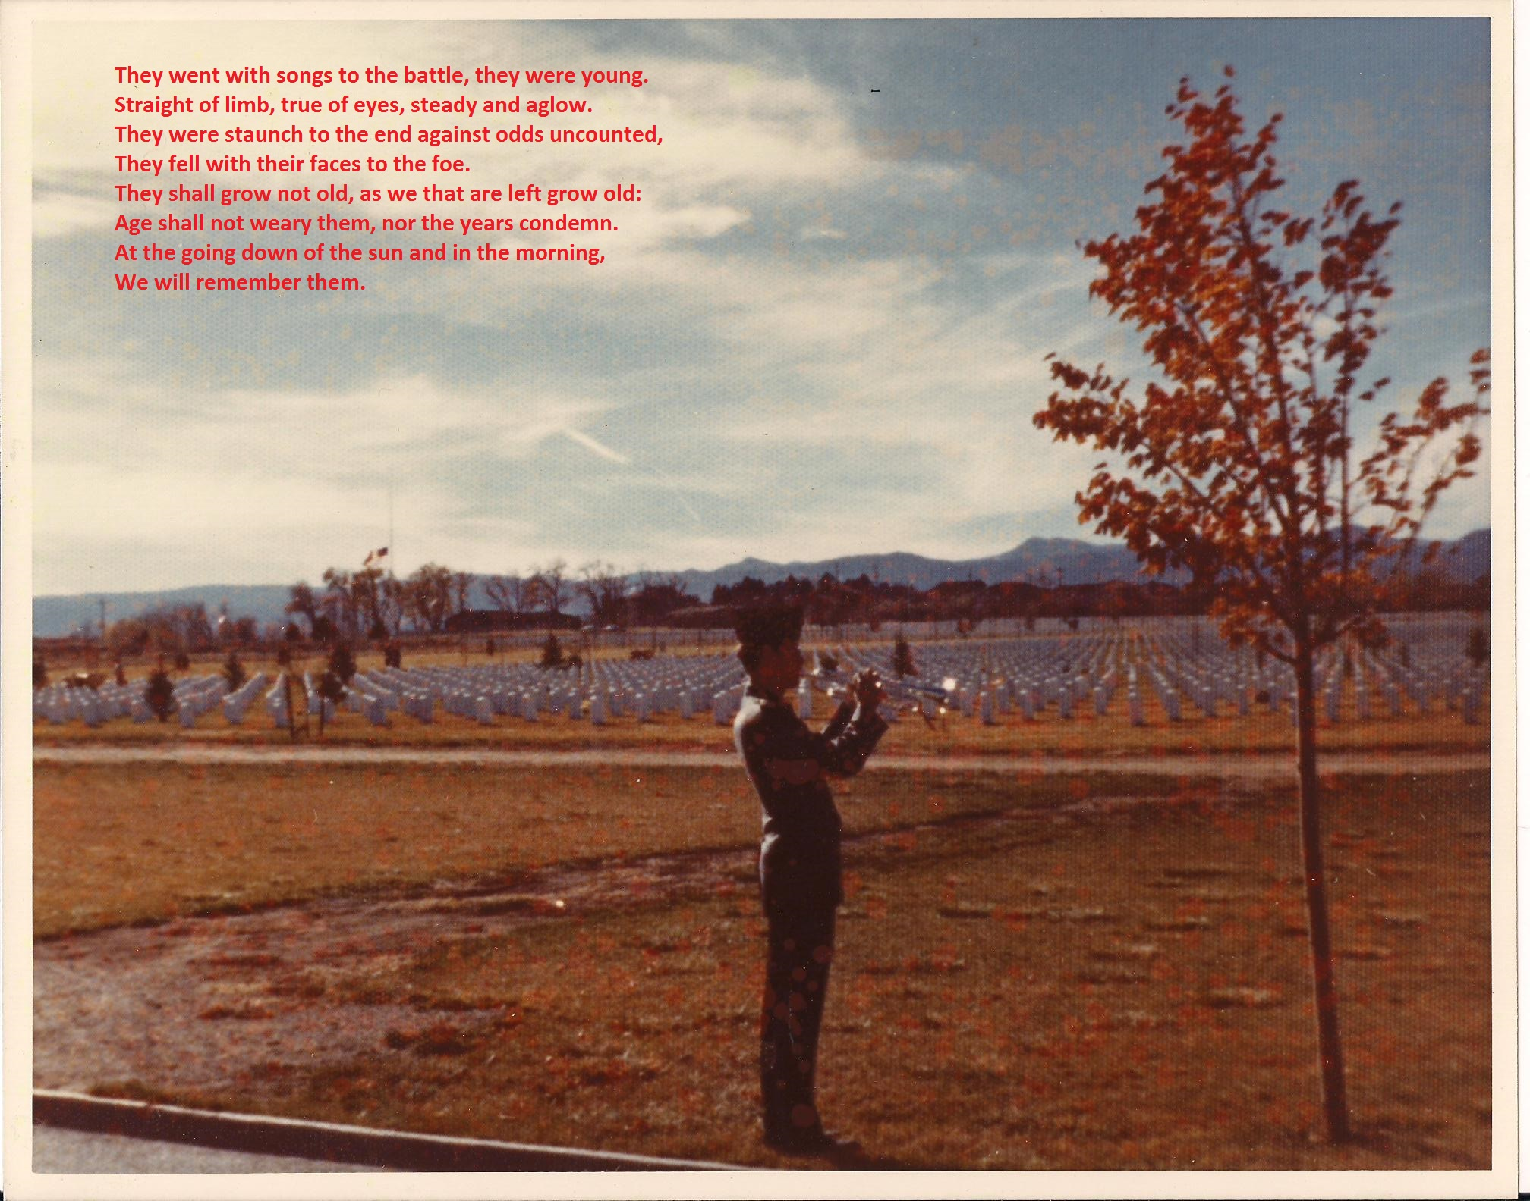

*Not his real name

