AN OLD MARINE REMEMBERS . . . . .

By Denis Nawrocki
Greenwood, IN

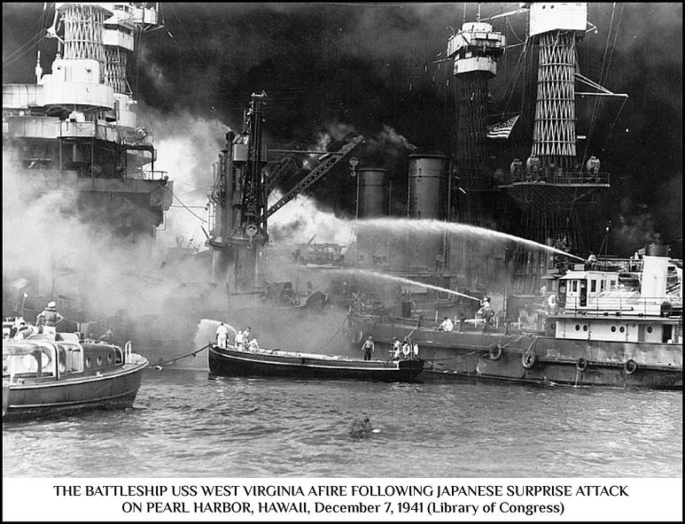

“. . . . a date which will live in infamy . . . .”

Let me see . . . . . yes, now I remember. It is December 7, 1941, and I am almost four years old. Along with my mom, dad, and older sister, Beverly, I live in a basement flat on Pennsylvania Avenue in Washington, D.C.

Dad is in the Navy and a member of the Naval Security Police. He and his fellow naval security agents patrol the Capitol District to keep our nation safe. When I open the front door and climb the seven concrete steps to the sidewalk on Pennsylvania Avenue, I can see the United States Capitol Building gleaming in the distance, and what a sight it is!

Today is Sunday, the 7th day of December. It is now two-thirty in the afternoon, and we are sitting in the living room listening to the radio. Dad is not on duty today, so we plan to spend the day together in our flat. Beverly is reading, and I’m playing on the floor with my yellow truck and toy soldiers. Mom has just finished washing lunch dishes and is now sitting in her favorite chair, reading the Times-Herald newspaper. Dad is relaxing on the couch, eyes closed, listening to the football game between the Philadelphia Eagles and the Washington Redskins. The Redskins are winning.

Suddenly, the radio broadcast is interrupted with this shocking announcement: “We interrupt this broadcast to bring you an important bulletin from the United Press. Flash, Washington; The White House announces the Japanese have attacked Pearl Harbor!”

Dad jumps up from the couch, hurries to the radio, and quickly changes the station to CBS, where the scheduled program is about to begin. But instead of The World Today, John Daly is delivering this statement: “The Japanese have attacked Pearl Harbor, Hawaii, by air, President Roosevelt has just announced. The attack was also made on all military and naval activities on the principal island of Oahu.”

Mr. Daly barely finishes his short report when the harsh jangle of our telephone prompts Dad to react quickly. He picks up the receiver, listens to the message with a look of growing concern on his face, and then, without saying a word, opens the closet door and retrieves his uniform, pistol belt, and hat. Then, in one blurred motion, he kisses Mom on the cheek, bids a hasty but heartfelt goodbye to Beverly and me, and hurries out the front door without pausing to look back.

The next day, December 8, 1941, at 12:30 pm, President Franklin Roosevelt delivered the following message to Congress:

****************

“Mr. Vice President, Mr. Speaker, Members of the Senate, and of the House of Representatives:

Yesterday, December 7th, 1941 — a date which will live in infamy — the United States of America was suddenly and deliberately attacked by naval and air forces of the Empire of Japan.

The United States was at peace with that nation and, at the solicitation of Japan, was still in conversation with its government and its emperor, looking toward the maintenance of peace in the Pacific.

Indeed, one hour after Japanese air squadrons had commenced bombing in the American island of Oahu, the Japanese ambassador to the United States and his colleague delivered to our Secretary of State a formal reply to a recent American message. And while this reply stated that it seemed useless to continue the existing diplomatic negotiations, it contained no threat or hint of war or of armed attack.

It will be recorded that the distance of Hawaii from Japan makes it obvious that the attack was deliberately planned many days or even weeks ago. During the intervening time, the Japanese government has deliberately sought to deceive the United States by false statements and expressions of hope for continued peace.

The attack yesterday on the Hawaiian Islands has caused severe damage to American naval and military forces. I regret to tell you that very many American lives have been lost. In addition, American ships have been reported torpedoed on the high seas between San Francisco and Honolulu.

Yesterday, the Japanese government also launched an attack against Malaya.

Last night, Japanese forces attacked Hong Kong.

Last night, Japanese forces attacked Guam.

Last night, Japanese forces attacked the Philippine Islands.

Last night, the Japanese attacked Wake Island.

And this morning, the Japanese attacked Midway Island.

Japan has, therefore, undertaken a surprise offensive extending throughout the Pacific area. The facts of yesterday and today speak for themselves. The people of the United States have already formed their opinions and well understand the implications to the very life and safety of our nation.

As Commander in Chief of the Army and Navy, I have directed that all measures be taken for our defense. But always will our whole nation remember the character of the onslaught against us.

No matter how long it may take us to overcome this premeditated invasion, the American people in their righteous might will win through to absolute victory.
I believe that I interpret the will of the Congress and of the people when I assert that we will not only defend ourselves to the uttermost, but will make it very certain that this form of treachery shall never again endanger us.
Hostilities exist. There is no blinking at the fact that our people, our territory, and our interests are in grave danger.

With confidence in our armed forces, with the unbounding determination of our people, we will gain the inevitable triumph — so help us god.

I ask that the Congress declare that since the unprovoked and dastardly attack by Japan on Sunday, December 7th, 1941, a state of war has existed between the United States and the Japanese empire.”

****************

Yes, I’m only four years old (well, almost), and probably too young to understand the meaning of these frightful events, but I will never forget the determined expression on my father’s face while heading for the front door with uniform, hat, and pistol belt in hand. Neither will I forget my mother’s mixed look of anxiety and disbelief as she watched Dad disappear through the door and up the seven concrete steps to the sidewalk on Pennsylvania Avenue.

