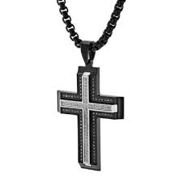
The Cross

My daughter gave me a necklace with a silver cross as a Christmas present last year. I wear it around my neck every day and never take it off. It serves as a constant reminder that I am a believer and a follower of Jesus Christ. He is my Savior, my Lord, and my best friend. Jesus is always with me. The cross I wear is close to my heart, reminding me that Christ is always close to me and loves me unconditionally. He will never leave me and never disappoint me, even when I am not always the way I should be. He forgives my sins, and as the Good Shepherd, he leads me on the right paths.

As a young boy I loved to sing the song, Jesus Loves Me. Whenever I sang this song it made me feel happy and warm in my heart. It gives me the same feeling today. Karl Barth was a world renowned Swiss theologian who once lectured at Princeton and at Union Theological Seminary. While he was in this country, a student at one of the seminaries said, “Dr. Barth, what is the greatest truth that ever crossed your mind?” All the seminary students were sitting on the edge of their seats to hear some great, profound, deep, complicated answer. Dr. Barth slowly raised his great shaggy gray head and looked at the student and said, “Jesus loves me, this I know, for the Bible tells me so.”

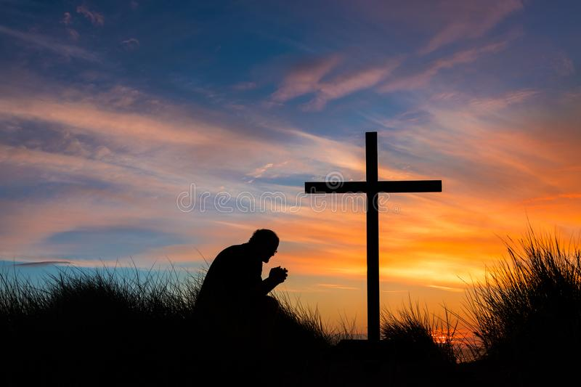

What does the cross mean to me? It means that Jesus loves me so much that he gave his life for me, and I want to live every day of my life for him. Every day there are opportunities to testify of his love and grace - by the words we say, the kindness we show, and the love we share with our family and friends and neighbors. As the scripture in Matthew 5:16 reminds us, “In the same way, let your light shine before others, that they may see your good deeds and glorify your Father in heaven.”

May the peace of Christ be with us all. In His precious name I pray, amen.

