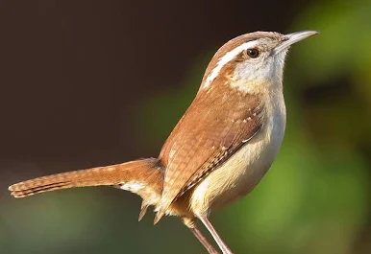

We have a family of Carolina Wrens living in a birdhouse on our deck overlooking Golden Acres Stream. Their wings and tail are a medium shade of brown and their underbellies are tan and white. Their tails are turned upward and their legs are straight and strong. Their slender beaks are just long enough for eating insects, which they feed to their young fledglings in the nest. I love them so much and look forward to seeing them every day they are with us in the springtime.
For about two weeks I watched the male wren carry nesting materials to the birdhouse in hopes of attracting a nice female wren to the nest. Finally a female came to investigate, and lo and behold it met with her approval and she stayed. After giving her approval and settling into their new nest home she soon laid her two eggs and their family began. Last week I watched as the male brought small insects to feed the chicks that had hatched. I really looked forward to the day when I would finally see the new wrens that were growing up.
Now they are taking turns bringing food to their chicks, every morning and every evening - so exciting.
This daily feeding can take up to 12 weeks before the fledglings are ready to leave the nest and go out on their own. It’s very exciting to watch the daily activities of my new wren family. God is truly amazing, creating and caring for these beautiful creatures and the lovely nature in our Golden Acres. We are very blessed indeed. Now they’re ready to stick their necks out and leave the nest, flying away into our surrounding nature. It’s been wonderful to see all this on our deck, thanks be to God. Amen.

Gene A. Groner USMC
Kansas City VA

