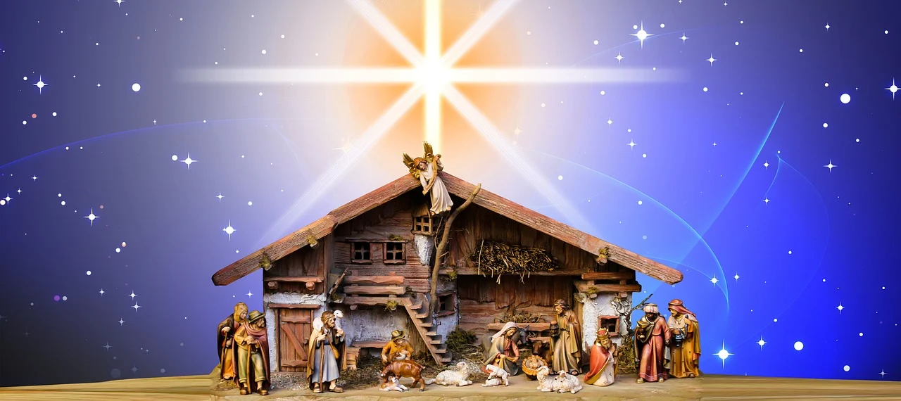

Starlight

True light sent from Heaven above
Shining from God’s eternal love

Starlight starbright into the night
All the glimmering points of light

Lighting the path to Bethlehem
Angels’ light and heavenly hymn

Through the ages brightly shine
Glorious light, light divine.

