Joe Squeo November 27, 2023

Goooooood Morning Vietnam
It was one of those more memorable miserable days out of 365 days spent in Vietnam. It started off like any other miserable day in a war torn country. The night before was an anxiety fillled night with fear. Charlie ^{l} had started the night with a wake up rocket attack around two in the morning. You never fully went to sleep as long as you knew Charlie was lingering around. Charlie was winning his vesion of psychological warfare especially at night. Charlie ruled the night.
Charlie's other psychological tool was using the radio airwaves day and night. I'm not sure how we G.l.'s were able to pick up the voice of Hanoi Hanna² . Most of the time we would tuned our transitor radios into Armed Forces Radio but every now and then we searched to hear the sultry voice of Hanoi Hanna. I'm not sure if we deliberately searched for her voice out of curiosity or defiance. She was able to inturupt our frequency and get into our heads. Her greetings began with, "How are you doing, G.I. Joe?" Then she would go on to tell you the news back in the USA. She would mix in good "Soul Music"and "Rock & Roll" anti-war songs. Most of her soul music selections were aimed at
Black G.l.'s telling them how hopeless it was to fight a "White Man's War" after MLK's assination and race riots back home. Every now and then she'd broadcast birthday greetings to a G.I. recently killed in action, or read Dear John Letters from home. She'd playfully warn about upcoming VC attacks. One time her warning was about blowing up our chow hall the next morning. Another time the warning was about destroying our outdoor movie theater during the movie "Patton." We'd laugh and defy her doom and gloom predictions and show up to see action.
Armed Forces Radio Vietnam Network (AFRVN) was clever in its approach of winning the minds and hearts of American G.l.s. Anyone who ever saw the movie "Good Morning, Vietnam" got the Hollywood version most of it fiction. Adrian Joseph Cronauer, the Amed Forces radio personality in 1966, inspired the 1987 film Good Morning Vietnam starring Robin Williams as Cronauer.
According to an interview years later Cronauer said the only true part of the script was the long drawn out morning greeting. The greeting was long and drawn out for good reason. Cronauer was trying to buy time trying to get his act together as he started to get on the air.

I "Charlie" the nickname given to the enemy. Sometimes refered to as Victor Charles, Viet Cong or VC
2 Hanoi Hanna— Communist North Vietnam Radio personality during the Vietnam War
Too bad most Deoole never heard the real Vietnam soundtrack. The morning show was called ze Dawn Busters it aired at 0:600 DaNang time. Various DJs hosted the show. One memorable DJ after
Cronauer was Pat Sajak of Wheel of Fortune fame.
I wish I could remember the Dawn Buster DJ after the rocket attack that took place. I do remember the first song that morning was "Good Day Sunshine" by the Beatles followed by "NV nat a Day for a Daydream" by the Lovin Spoonful. I soon realized I could survive the night norrors DY keeping my transistor radio closeby.
Later that day the familiar song "Fortunate Son" played on the radio. The uplifting music made me believe I was a fortuate son who could servive my remaining days left in Nam.
Keeping an open mind I decided to look back on my four years in the military and write aoout my exeriences in the late 6(Ys.
i was and still am a fortunate son.

ROCKET ATTACKS
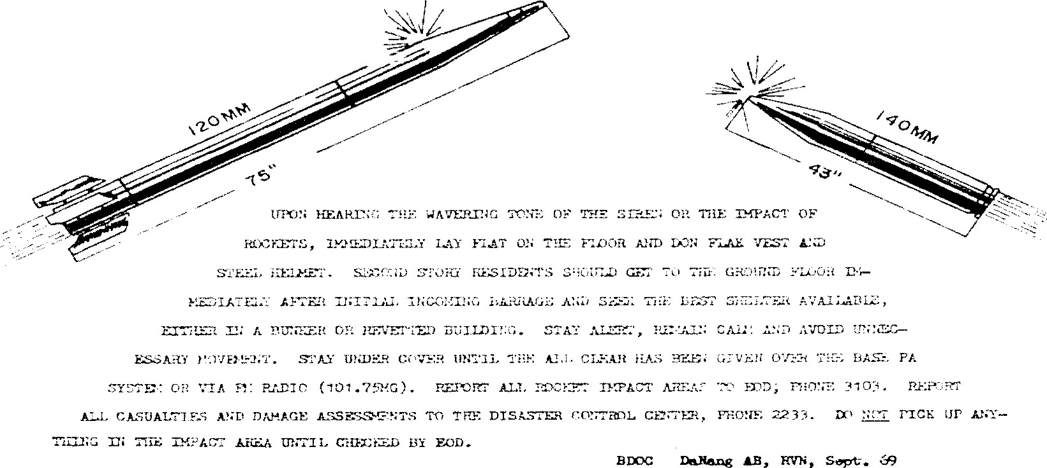
Warning Notice l: What to do during a rocket attack. Danang Air Base was known as "Rocket
City Due to.frequent allacks. This' warning was dated September 1969
Rocket Attack Warning Notice Photo by: Paul Jacob 366th AMS

