Why Not Me?
Why not me?
To be compassionate.
To be nice
To be kind
To care
In todays forum
Regardless of religion, race, sex, who you love,
To follow what is left of the law Why not me?
Is big brother watching you?
What you say?
What I write?
Why not me? A resistance against
What is wrong
With America?
Am I all wet? Am I wrong?
Please help me!!
I mean no harm!!
I fought the good fight!
Did my duty!
Served my country!
Paid the price! Now?
I am lost
In a sea of doubt
Nowhere to turn
What is left of Lady Liberty?

Why not me?
I can not give up! No surrender!
Improvise!
Overcome!
Taught to me at 18, 19, and 20
Now in a few months 75 What lies ahead?
For my E-3 Air Force grandson?
What kind of a world?
What kind of United States?
The one I fought for in Vietnam.
Why not me? Who raised that current day airman!
What do I tell him? And he —his father-my other son
All disagree with me!
I don't know! Throw me a lifeline!
Am I confused? Blind to what is going on?
Computer software programs that track every single
Keystroke !
In the federal government!
Why not me?
It has to start somewhere
Where it starts—who starts it—why it is started
Does not matter! As long as it starts!
Why not me? I am prepared! I lived sacrifice
Many years ago.
I remember!
All for the better good!
To be compassionate
To be nice To be kind
To care!
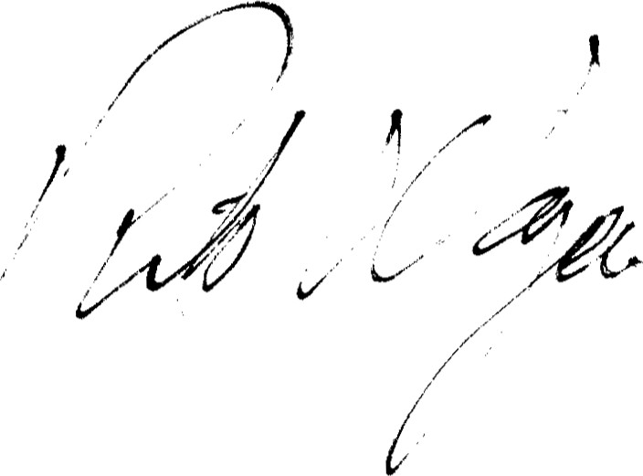
Mr. Richard Wangard
134 Alexander Dr
Neenah, WI 549564838

