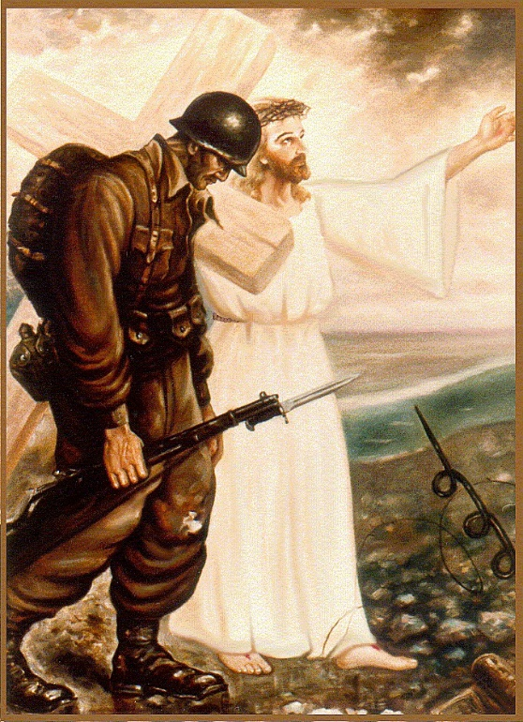
What manner of men are they?
Stalwarts! They who sacrificed
and bore the brunt of war
upholding the banner of freedom.
on distant sandy shores
Ready rifles held in sturdy hands
they were so young and, in their teens,
heroes blemished by the toils of war
carrying flagellum scares.
Country boys and backwoods fellas
city folk and college kids
youthful eyes reflecting sorrow
by the heavy hearts they carry
faces of their foes etched in their mind
the stench of war rendering them soiled
with wars cruelties in ebony fringes
evident in their remorseful gate,
as they walk with repentant souls.
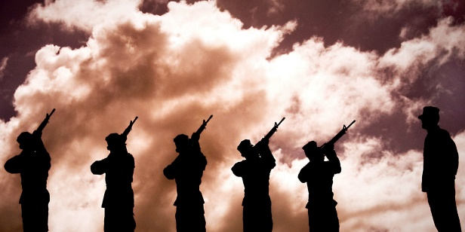

We’ll Never Walk Together Again

There is an essence that fills our souls,
Yet, we wonder if everything will be alright.
held together by that jungle that closes upon us.
yet we’re afraid to move on.
with gratitude in our chest our heart beats,
we are alone,
So why do we have to die?
Whose robbing us of our lives?
We see faces buried in our minds,
We were taken away from home,
where love is supposed to wait.
But what is love when we’re not there,
and will they still love us?
Those monsters we have become!
And who are they that we lived with,
fought with, and died with.
Our Brothers;
We did our part,
but
we’ll never walk together again.

