The Diary of Dr. Destruction
Brief Poem by Mike Irwin

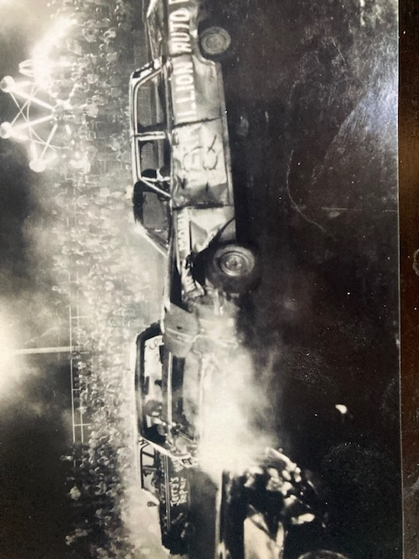

Just bought an old Ford , Fairlane 500
It’s sittin in the driveway gettin ready for the derby
The glass is all gone the numbers painted on
She’s ready for destruction come Saturday night.

The flag went down the junkers spun around
Crashing into one another calling one another a mother
The guy from Spink hit me head on
I’m ready for destruction come Saturday night!

The stands were crowded and all the fans shouted
For the one they wanted to win but my chances look pretty grim
You see there’s steam commin from my radiator
I’m nearing destruction come Saturday night

Through the smoke and confusion I’s having the illusion
That I’d be the winner take my wife out to dinner
But I’ve got double vision from that last collision
I’m closer to destruction come Saturday night

My dreams were all shattered when my left side was battered
By an orange Plymouth wagon who’s tailgate was draggin
Now I’m sitting here fresh out of luck waitin for the junkyard tow truck
But I’ll be back next year, I’m the Dr. of Destruction come Saturday night.

