Grandpa Henry

I’ll always remember my grandpa Henry sitting in his large, maroon upholstered easy chair reading the newspaper, the Daily Democrat News. He was usually smoking a cigar—he liked El Roi Tans—or a Camel cigarette. Grandma Ada never smoked, but Henry did—cigars and Camel cigarettes. In front of his tin shop on Arrow Street just off the city square, where he made sheet metal fabrication for gutters, furnaces and other things for businesses around town, there was a pool hall with 4 billiard tables and 2 large snooker tables. I would go there sometimes and watch the older men play pool and smoke cigars—the place was always filled with smoke. They kept score with small wooden spools that slid along heavy wires above the pool tables. I would buy used decks of playing cards, after the men had used them a while in the back room where they played poker. I could buy a deck of cards that way for only a nickel. Coca Cola came in bottles, and they cost 10 cents in the big red dispensers. Then I would go to the back of the poolroom where grandpa had his tin shop and watch my grandfather cut and shape sheet metal on a large iron breaker machine, which he operated by hand—there was little automation back then. It fascinated me to watch him work. He was well respected and very good at his trade, which he referred to as “tinsmith.” At home in the evening, while he sat smoking in his easy chair, I would get down on the oak floor in front of him and do push-ups to impress him. I could do a lot of push-ups, and that practice I got at home helped me become the top push-up guy at boot camp in the Marines. I could do more than anyone else, which was a source of great pride. While working on a rooftop one day, he fell and broke his leg. After that he always walked with a cane. He drove a 1941 Plymouth sedan, dark gray, and in 1952 he drove to the Nash dealer in Marshall and traded it in on a brand-new light gray Nash Ambassador. He was a big man, and the Ambassador gave him plenty of room. He never used credit, and he paid for the Nash with cash. That’s what I remember about Grandpa Henry. I loved him and Grandma Ada, and I miss them very much. I couldn’t ask for better grandparents. 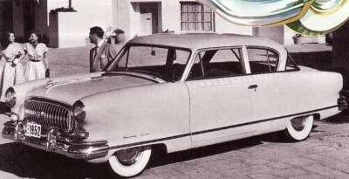 1952 Nash Ambassador.

