House Wrens
Ireland's Wildlife
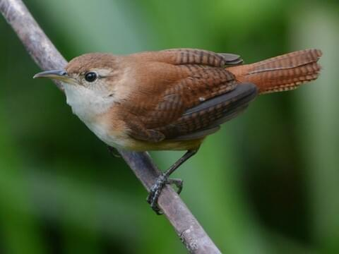
480 × 360

We have a family of house wrens living in a birdhouse on our deck. They are brownish above and somewhat paler below, with strong legs. Their short rounded wings and frequently cocked tail have a dark barred pattern. The flight is direct and buzzing, sort of reminding us of the hummingbirds we see from time to time.

For about two weeks I watched the male wren carry nesting materials into the house, and I hoped that he could attract a female wren to nest there. At last, she came around to check it out and see if it met her standards. It is said that a male wren needs to build up to seven different housing sites in order to get a female to approve of one. She can be very particular.

After careful inspection, she gave her approval and began settling into their new home. Soon, she laid her eggs and the two of them too turns keeping the eggs safe and warm. Last week I noticed them beginning to bring small insects to feed their chicks. I don’t know how many chicks there are, but I read that there can be as many as four little ones in a nest. I don’t know just how many eggs she laid, but I hope to find out when I see the chicks eventually leaving the nest. I’m really looking forward to that day.

The male and female are very busy now, taking turns bringing insects to feed the little ones every morning and every evening. This will continue for up to 12 weeks before the young birds are ready to leave the nest and be on their own. It’s very exciting to watch all the activities of this wonderful wren family. God is truly amazing, creating and caring for nature and all her magnificent creatures. And we are so fortunate to live in a wooded area where the wildlife is abundant. Thanks be to God.

