“Living Water”
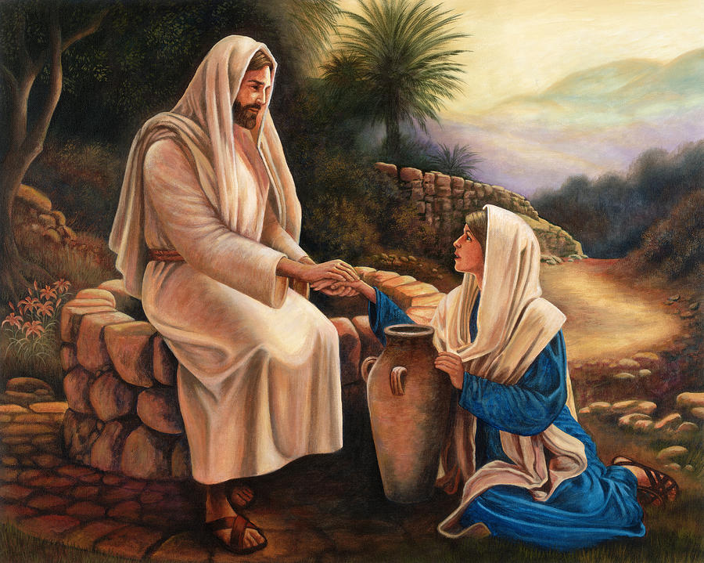
900 × 7
“The water that I will give will become a well of water springing up to eternal life.” These are the words of Jesus that he spoke to the woman of Samaria that warm summer day. She was thirsty. He gave her water to drink. She was tired. He offered her rest for her soul. She was weary of the life she had lived. He gave her a new life and a new hope for the future.
She had many husbands. Jesus told her she only needed one. He was the one she needed. Jesus is the one we need. He is the “Living Water.”
Behind my house is a living spring. Every day it brings forth fresh water from the earth. It never fails, never falters, never forgets. Fresh, clean water every day, without missing a drop.
When I think of the water from our living spring, It reminds me of Jesus and his everlasting love, the kind of love I need. I am no different than the woman from Samaria.
We are the same, she and I. We both drink from the same well, the well touched by the hands of Jesus.
The same hands that healed the blind and the lame. The same hands that blessed the bread and the wine. The same hands that prayed to the Father. The same hands that blessed the little children, that lifted the fearful and nearly drowning Peter from the stormy sea, and raised Jesus’ friend Lazarus from the dead.
Hands that will never grow old or tired. Kind hands that are made for blessing and for healing and for holding us in his loving arms.
Hands that are full of love for the poor. Hands reaching out to help and to bless and to forgive.
How I love those hands. Those are the hands that I long to touch and to hold. Those are the hands that we all want and need to hold. Those are the hands that created the world. Those are the hands that heal the broken-hearted. One day those same hands will carry us home. Home to the place where we belong.
Home to the place of light and love. Home to the place where the Father waits for us. Home to the place of living water. That’s our eternal home. And that home is Heaven.

