You are just one part of a box full of goodies or not so much good products for you, certainly not enough

Example- for example three cancer sticks provided time sure have changed

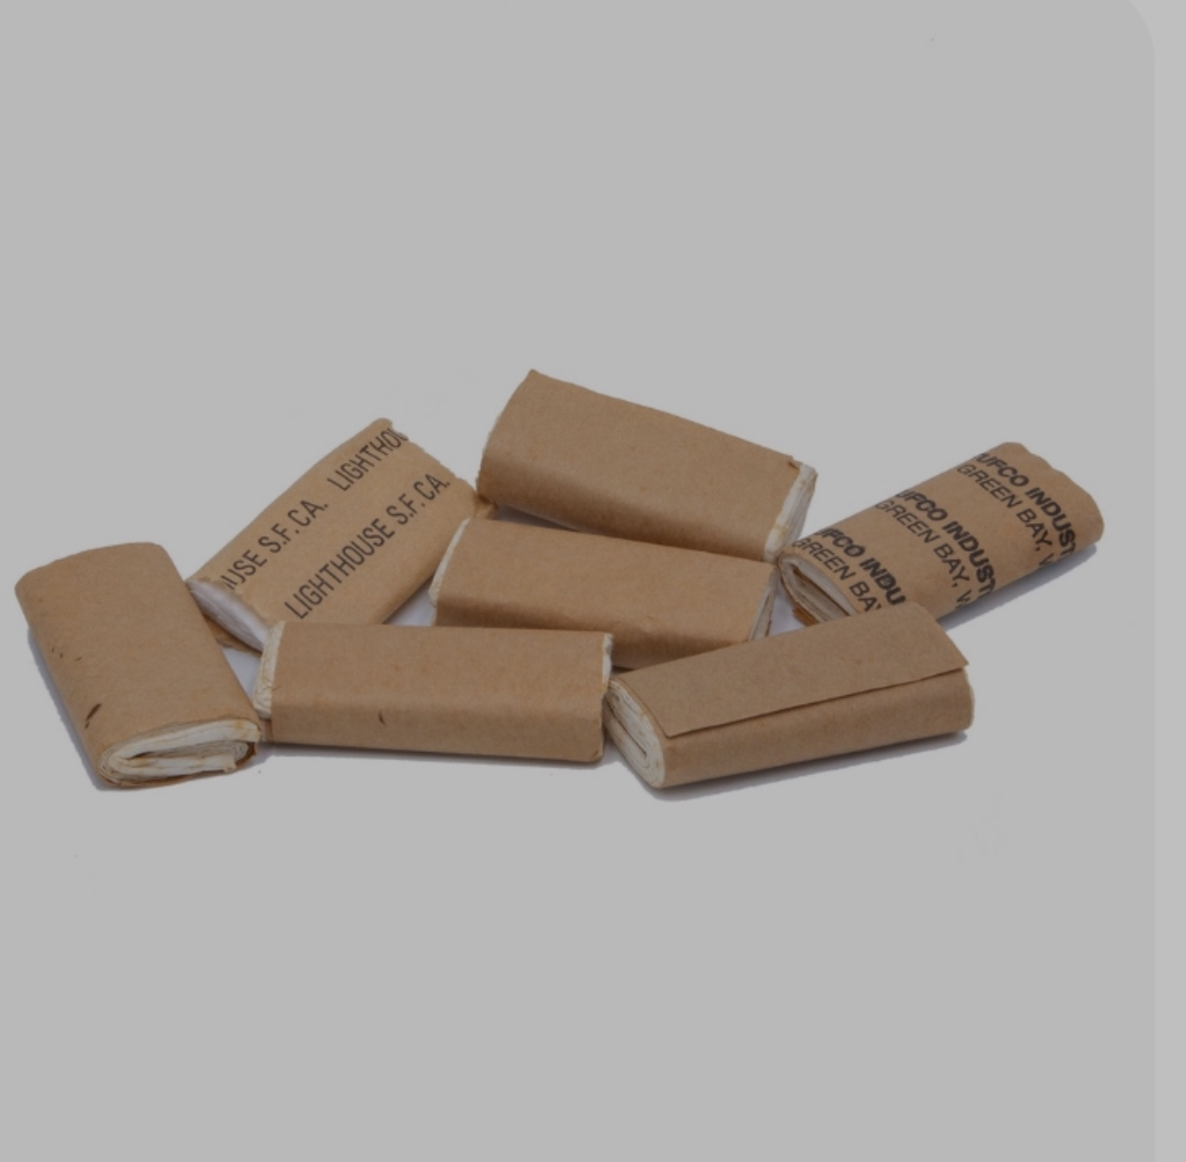
It’s certainly not enough

You certainly didn’t have women in mine when you created and packed the items in the C-rats Cira 1975 or before.

Personal hygiene certainly wasn’t a priority, if so theycertainly failed it miserably

I’m kind of curious if we should use what’s provided for you naturally or what the people who physically live in this country uses such as their left hand, leaves, sand,

Probably couldn’t be any better than this rough sandpaper like item, even the sound of crinkling nondisposable ,except by fire.

