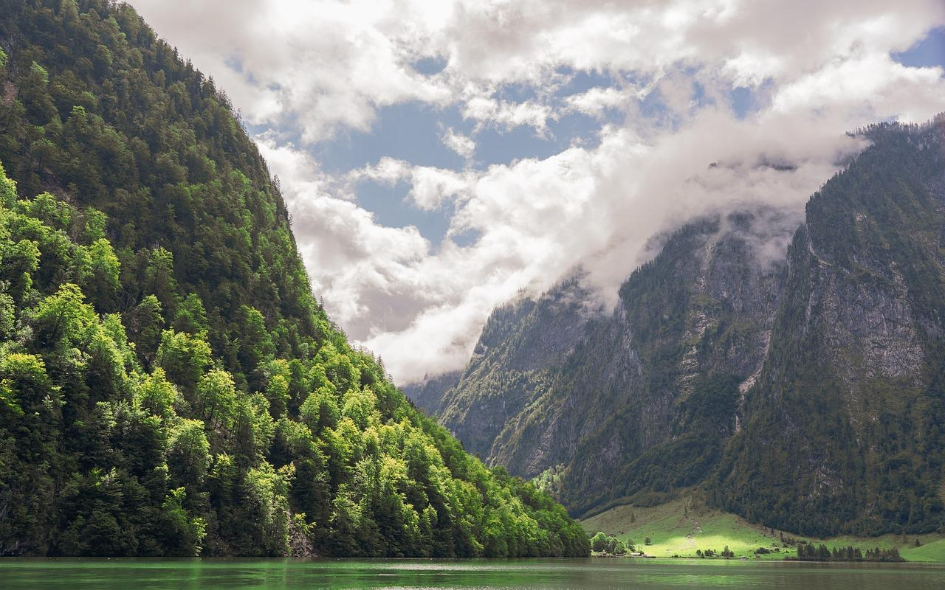

Heaven

I’m on my way to heaven
The place where I belong
Each day I dream of heaven above
My heaven abounding full of love

A place where there are no more tears
And no more pain to feel
For heaven is my resting place
All fear is gone, there’s only peace

Peace in heaven is my destiny
The place where I have longed to be
One day I’ll soar above the clouds
And there I’ll once again be free

Free to laugh and love and be
Where all my loved ones I will see
My heart is there and soon I’ll be
Finding joy in eternity
Happy are those who find their way
Along the pathway through the sky
Sailing the earthly sea of life
To happier times and joyful mirth.

