I wish I can say I’ve given up being angry, unfortunately the nasty monster just comes out of nowhere.

That is until I can regain the common sense to calm down that little critter.

my theory is you can’t have peace if you’re feeding that tiger,

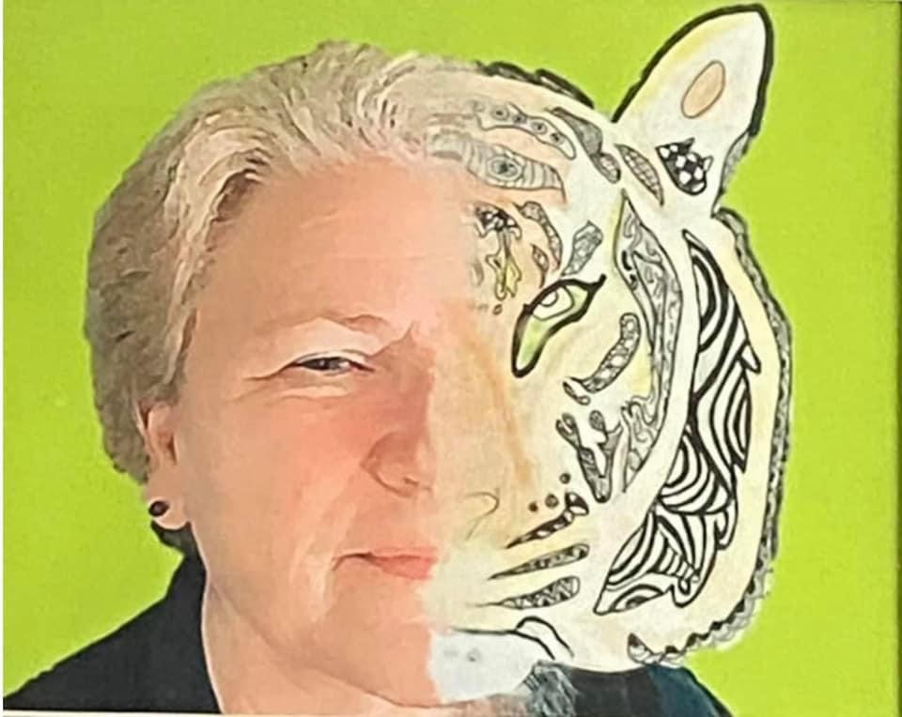
so I try my best to coax the positivity feeling out little by little,
having them show themselves
like a short shadow early in spring

Having the faith that one day I take notice of the shadow

She is strong sturdy moving forward along side me

not dragging me down

after all nothing including energy can occupy the same space at the same time

with peace there is love, a kind of happy, a calmness within,

no room for the others

