The Holy Bible
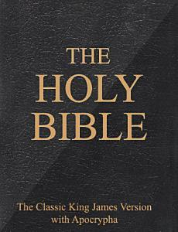
Having read hundreds of books over my lifetime, and written and edited numerous books and articles, I have never seen or heard of any book to compare with the Holy Bible. An estimated 5.6 billion copies of the Bible have been purchased worldwide. It has been translated into 698 languages and sold in over 100 countries. Each year approximately 100 million Bibles are purchased throughout the world. You can now have access to the Bible in braille, in audio version, and in digital formats. The Bible is by far the most widely read and easily accessible book ever written.
I received my first Bible from my grandmother Ada Spohrer. She gave me a set of the three standard books of the church upon my high school graduation from Marshall High School in Marshall, Missouri. I still have them and cherish them in my library today. I never tire of reading them, for in them I have encountered God and Christ through the Holy Spirit many times. Their value to me cannot possibly be measured in material terms. Each time I pick up one of these books, I remember vividly my grandmother and my mother. They faithfully brought me to church twice a week, just one of the many ways they showed their love for me, for our Heavenly Father, and for our church. It was in their home that I first read the Saints Herald, and I’ve been reading it ever since. I learned from my mother and grandmother what it means to value and to love family, friends, church, and most of all God and Jesus Christ.
Today I have a number of different versions of the Holy Bible. I find it useful to compare readings from several of them, as clarity and readability vary from one to another, especially when I am studying and preparing to speak or write about a particular scripture or theme. By reading from various scriptures, I am better prepared, and I find it easier to understand the underlying message. Knowing the scriptures also strengthens my faith and fortitude whenever temptation calls. Jesus, when tempted by Satan in the wilderness, was able to resist temptation by quoting scripture.
I have learned to memorize various passages as a means of gaining the upper hand with the Tempter whenever the need arises. I believe this not only helps me, but more importantly it pleases my Father in heaven. I recommend the memorization of scripture from an early age and on throughout our life here on earth.

Gene A. Groner USMC
Kansas City VA

